I N D E X

|  |  |  |  |  |
| --- | --- | --- | --- | --- |
| **Sr.**  **No.** | **Date** | **Particulars** | **Page No** | **Signature** |
| **1.** | 19/09/2022 | Create a database named with ‘mydb’, Create a collection named ‘employees’, Insert 15 documents in it. | 3 |  |
| **2.** | 19/09/2022 | Write a MongoDB query to displays all documents from the employees collection. | 14 |  |
| **3.** | 19/09/2022 | **Write a MongoDB query to displays name, joining date and salary of all documents from the employees collection.** | 14 |  |
| **4.** | 19/09/2022 | **Write a MongoDB query to displays first name, last name and email id of all documents from the employees collection whose salary is more than 20000.** | 15 |  |
| **5.** | 19/09/2022 | **Write a MongoDB query to displays first name, last name, email id and contact number of all documents from the employees collection whose salary is 20000 and working as an ‘Web Developer’.** | 15 |  |
| **6.** | 19/09/2022 | **Write a MongoDB query to displays all documents from the employees collection whose first character of their first name is ‘K’.** | 16 |  |
| **7** | 19/09/2022 | **Write a MongoDB query to displays all documents from the employees collection in the ascending order of their birth year.** | 16 |  |
| **8** | 19/09/2022 | **Write a MongoDB query to displays top 5 documents from the employees collection earning highest** | 17 |  |
| **9** | 19/09/2022 | **Write a MongoDB query to remove all the documents whose pincode is 395001.** | 17 |  |
| **10** | 19/09/2022 | **Write a MongoDB query to displays all documents from the employees collection born on or before 1990.** | 18 |  |
| **11** | 19/09/2022 | **Install Nodejs, Create React one react application with “Myfirstapp” name and Run it.** | 18 |  |
| **12** | 19/09/2022 | **Write a React program to create Header, Navbar using Bootstrap.** | 20 |  |
| **13** | 19/09/2022 | **Write a react program to create Form with Name, address, Gender, Subjects (dropdown box), Hobbies (check box) submit the form and alert the inputted data.** | 21 |  |
| **14** | 19/09/2022 | **Write a React program to count button click event using ‘useState’ hook.** | 23 |  |
| **15** | 19/09/2022 | **Write a React program to create Timer using ‘useEffect’ hook.** | 25 |  |
| **16** | 19/09/2022 | **Create Single page application (Website) using Angular js.** | 27 |  |

**1) Create a database named with ‘mydb’, Create a collection named ‘employees’, Insert 15 documents in it.**

**Code:**

use("mydb");

**Screenshot:**

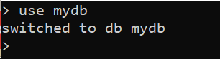

db.createCollection("employees");

**Screenshot:**

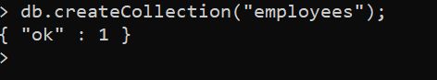

db.employees.insert([

{

empno:2001,

name:[

{

firstname:"Chintan",

lastname:"Bhimani"

}

],

emailID:"bhimanicaa@gmail.com",

contact:1234567890,

designtion:"Web Devloper",

birthday:new Date("2003-03-31"),

joiningdate:new Date("2020-01-01"),

salary:20000,

department:[

{

name:"IT",

discrition:"Information Technology"

}

],

address:[{

city:"Ahmedabad",

state:"Gujarat",

landmark:"Vesu",

pincode:395001

}]

},

{

empno:2002,

name:[{

firstname:"Rahul",

lastname:"Makvana"

}],

emailID:"rahul111@gmail.com",

contact:6754534567,

designtion:"Police Officer",

birthday:new Date("1988-02-11"),

joiningdate:new Date("2000-11-27"),

salary:54000,

department:[{

name:"Police",

discrition:"Police Department"

}],

address:[{

city:"Surat",

state:"Gujarat",

landmark:"Adajan",

pincode:395011

}]

},

{

empno:2003,

name:{

firstname:"Nikunj",

lastname:"Ghori"

},

emailID:"nikunj32@gmail.com",

contact:9765694596,

designtion:"Assistant Professor",

birthday:new Date("1995-11-11"),

joiningdate:new Date("2015-06-01"),

salary:15000,

department:{

name:"School",

discrition:"School Department"

},

address:{

city:"Vadoadara",

state:"Gujarat",

landmark:"Adajan",

pincode:399101

}

},

{

empno:2004,

name:[{

firstname:"Minal",

lastname:"Ramani"

}],

emailID:"minal02@gmail.com",

contact:5676567545,

designtion:"Software Devloper",

birthday:new Date("1999-09-04"),

joiningdate:new Date("2019-01-01"),

salary:56999,

department:[{

name:"IT",

discrition:"IT Department"

}],

address:[{

city:"Mumbai",

state:"Maharashtra",

landmark:"Bandra",

pincode:4001069

}]

},

{

empno:2005,

name:[{

firstname:"Dhruvi",

lastname:"Patel"

}],

emailID:"dhruvi@gmail.com",

contact:234565437,

designtion:"Manager",

birthday:new Date("1976-05-06"),

joiningdate:new Date("2003-10-01"),

salary:91000,

department:[{

name:"AMT",

discrition:"Social Service"

}],

address:[{

city:"Junagadh",

landmark:"Gir",

pincode:564345

}]

},

{

empno:2006,

name:[{

firstname:"Kirti",

lastname:"Mital"

}],

emailID:"mitalisha000@gmail.com",

contact:098786745,

designtion:"Tester",

birthday:new Date("1988-02-11"),

joiningdate:new Date("2000-11-27"),

salary:24000,

department:[{

name:"Find Technology",

discrition:"Checking Software Depaetment"

}],

address:[{

city:"Dilhi",

state:"Uttar Pradesh",

landmark:"West Delhi",

pincode:888888

}]

},

{

empno:2007,

name:[{

firstname:"Chirag",

lastname:"Jasani"

}],

emailID:"chirag01@gmail.com",

contact:0005605656,

designtion:"Owner",

birthday:new Date("1992-12-17"),

joiningdate:new Date("2017-12-01"),

salary:null,

department:[{

name:"The Food Club",

discrition:"Hotel"

}],

address:[{

city:"Mumbai",

state:"Maharashtra",

landmark:"Juhu",

pincode:400376

}]

},

{

empno:2008,

name:[{

firstname:"Akshay",

lastname:"Kaneriya"

}],

emailID:"ak@gmail.com",

contact:978656789,

designtion:"Software Devloper",

birthday:new Date("2001-11-26"),

joiningdate:new Date("2020-03-01"),

salary:70000,

department:[{

name:"IT",

discrition:"IT Department"

}],

address:[{

city:"Surat",

state:"Gujarat",

landmark:"Vesu",

pincode:395001

}]

},

{

empno:2009,

name:[{

firstname:"Dhruvik",

lastname:"Vekariya"

}],

emailID:"dhukiii@gmail.com",

contact:123456543,

designtion:"IAS Officer",

birthday:new Date("2003-01-28"),

joiningdate:new Date("2022-01-01"),

salary:90000,

department:[{

name:"Police",

discrition:"Police Department"

}],

address:[{

city:"Mumbai",

state:"Maharashtra",

landmark:"Bandra",

pincode:401069

}]

},

{

empno:2010,

name:[{

firstname:"Darshan",

lastname:"Thummar"

}],

emailID:"darshan007@gmail.com",

contact:1230070076,

designtion:"Seles Manager",

birthday:new Date("2003-04-12"),

joiningdate:new Date("2022-09-01"),

salary:21000,

department:[{

name:"HTC Texttile",

discrition:"Texttile Department"

}],

address:[{

city:"Surat",

state:"Gujarat",

landmark:"Varachha",

pincode:395006

}]

}

]);

**Screenshot:**

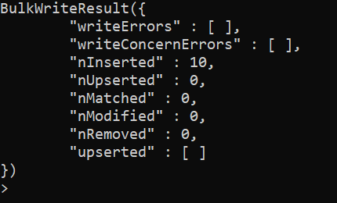

**2) Write a MongoDB query to displays all documents from the employee’s collection.**

**Code:**

db.employees.find().pretty()

**Screenshot:**

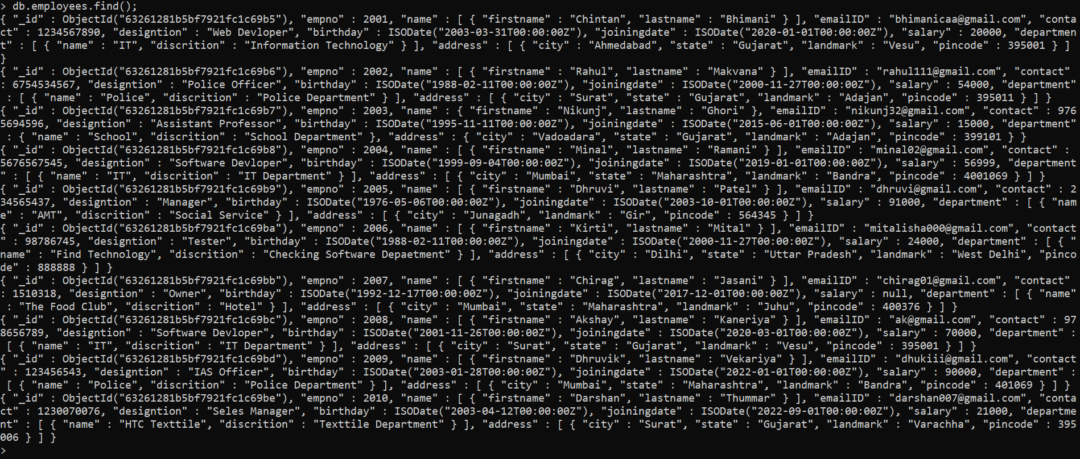

**3) Write a MongoDB query to displays name, joining date and salary of all documents from the employee’s collection.**

**Code:**

db.employees.find({},{name:1,j_date:1,salary:1,_id:0}).pretty()

**Screenshot:**

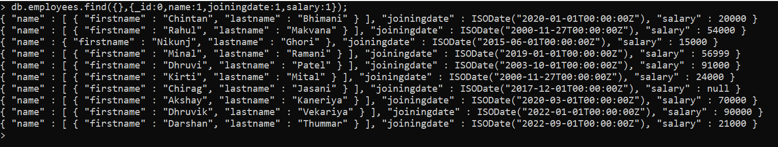

**4) Write a MongoDB query to displays first name, last name and email id of all documents from the employee’s collection whose salary is more than 20000.**

**Code:**

db.employees.find({},{_id:0,name:1,joiningdate:1,salary:1});

**Screenshot:**

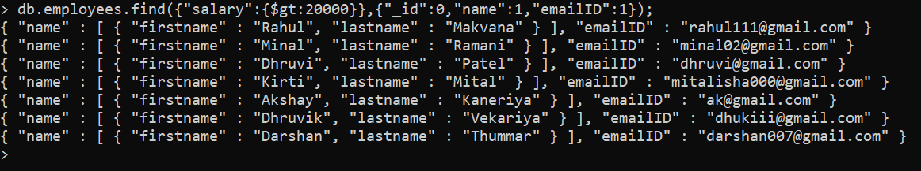

**5) Write a MongoDB query to displays first name, last name, email id and contact number of all documents from the employees collection whose salary is 20000 and working as an ‘Web Developer’.**

**Code:**

db.employees.find({"salary":{$gt:20000}},{"_id":0,"name":1,"emailID":1});

**Screenshot:**

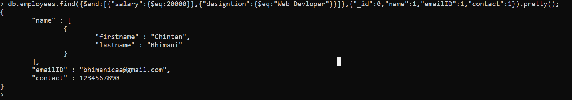

**6) Write a MongoDB query to displays all documents from the employee’s collection whose first character of their first name is ‘K’.**

**Code:**

db.employees.find({"name.firstname":/^K/},{"_id":0,"name.firstname":1}).pretty();

**Screenshot:**



**7) Write a MongoDB query to displays all documents from the employee’s collection in the ascending order of their birth year.**

**Code:**

db.employees.find().sort({birthday:1});

**Screenshot:**

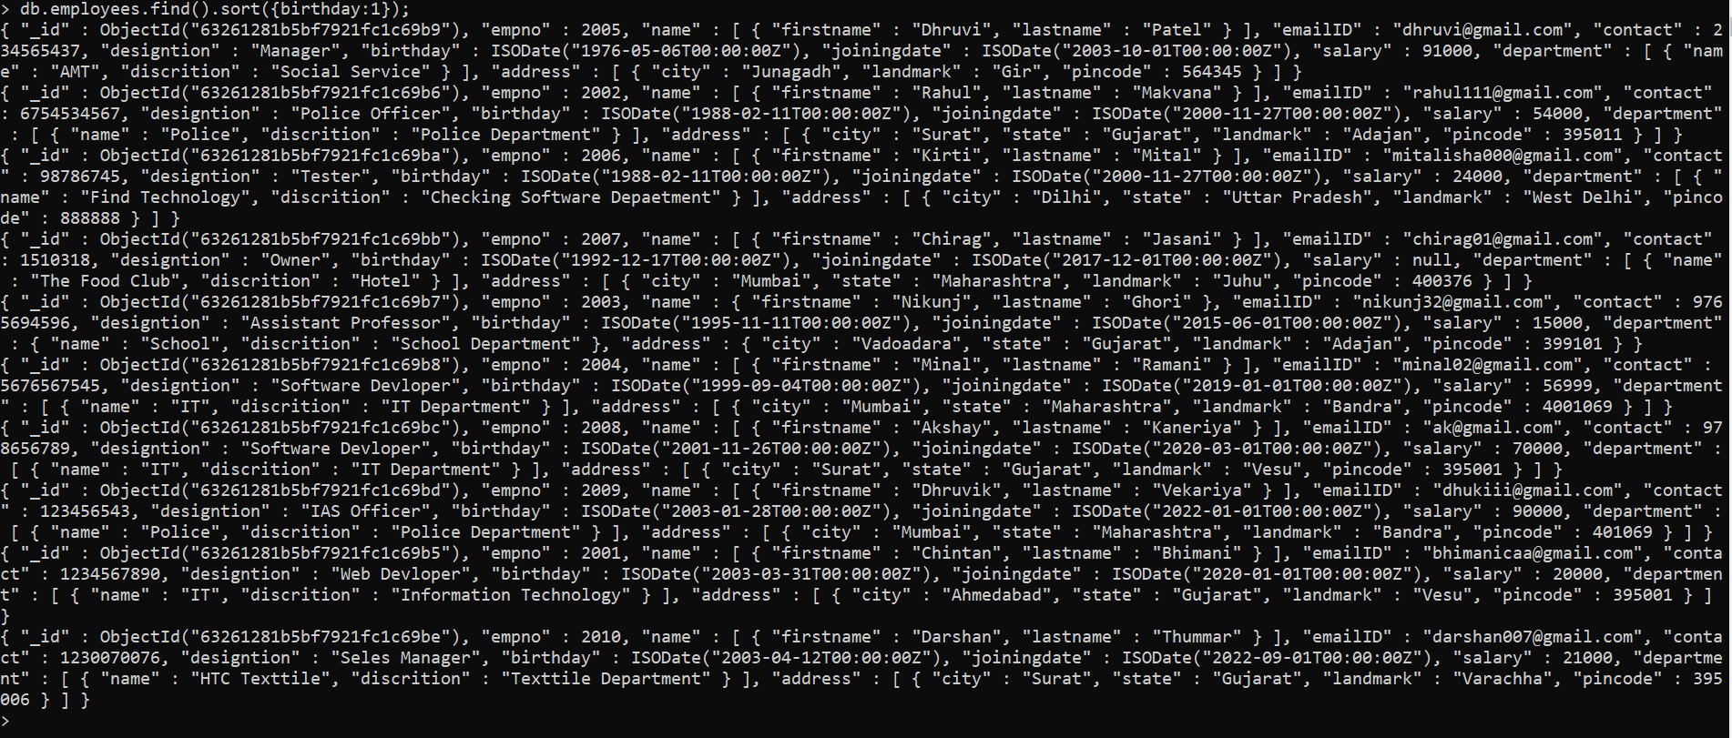

**8) Write a MongoDB query to displays top 5 documents from the employee’s collection earning highest.**

**Code:**

db.employees.find().sort({"salary":-1}).limit(5);

**Screenshot:**

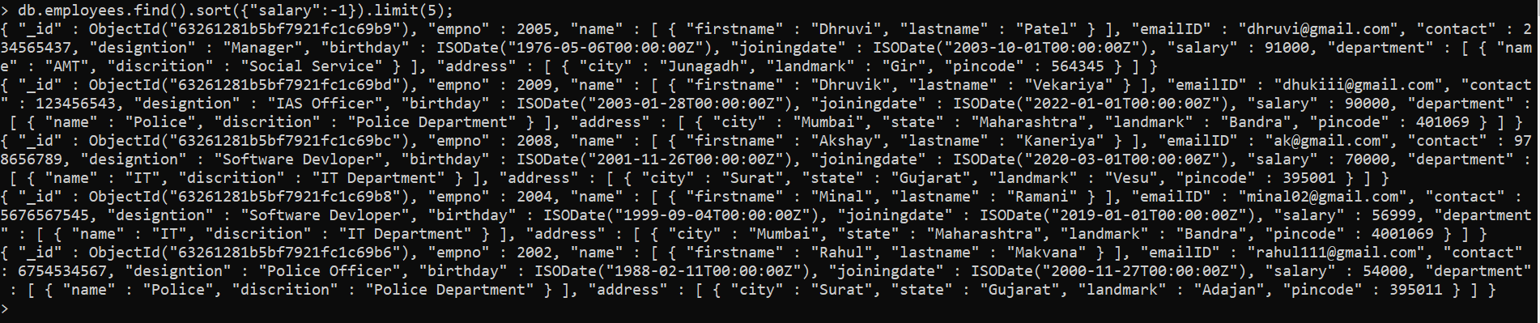

**9) Write a MongoDB query to remove all the documents whose pincode is 395001.**

**Code:**

db.employees.deleteMany({"address.pincode":395001});

**Screenshot:**

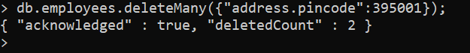

**10) Write a MongoDB query to displays all documents from the employees collection born on or before 1990.**

**Code:**

db.employees.find({"birthday":{$lte:ISODate("1990-12-31")}},{"birthday":1});

**Screenshot:**

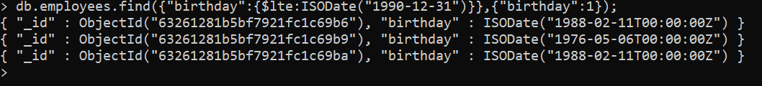

**11) Install Nodejs, Create React one react application with “Myfirstapp” name and Run it**

**Code:**

npx create-react-app myfirstapp

cd myfirstapp

npm start

**App.js**

import logo from './logo.svg';

import './App.css';

function App() {

return (

<div className="App">

<header className="App-header">

<img src={logo} className="App-logo" alt="logo" />

<p>

Edit <code>src/App.js</code> and save to reload.

</p>

<a

className="App-link"

href="https://reactjs.org"

target="_blank"

rel="noopener noreferrer"

>

MyFirstapp

</a>

</header>

</div>

);

}

export default App;

**Screenshot:**

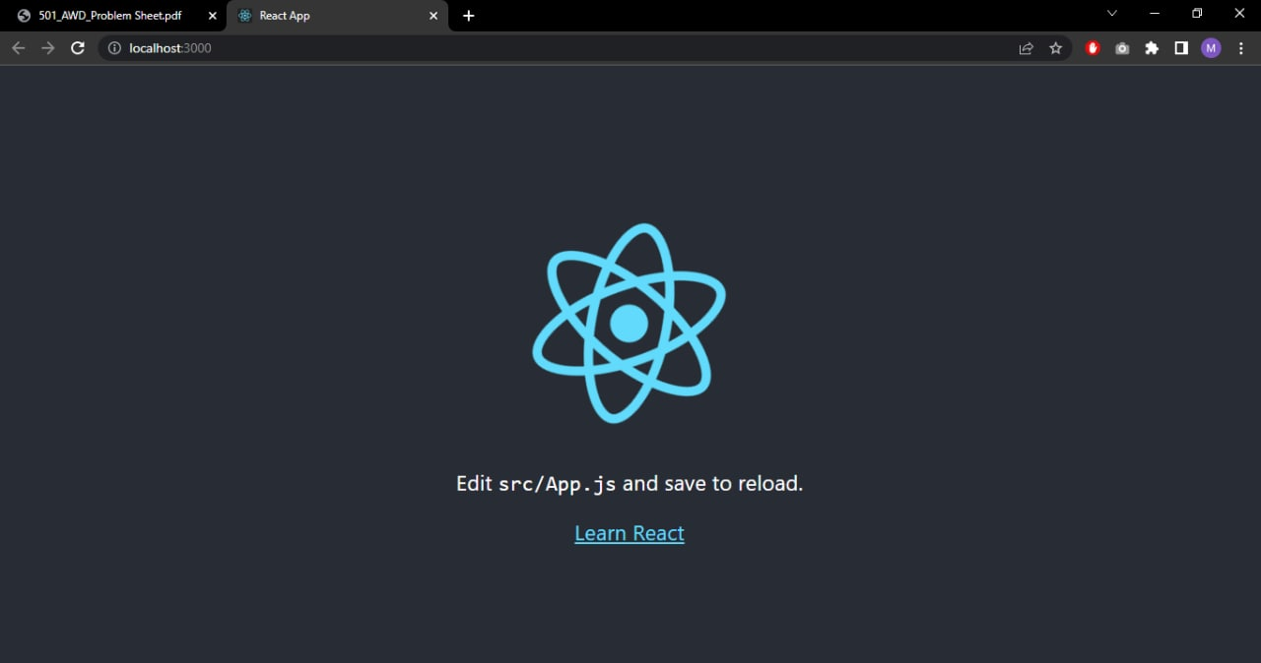

**12) Write a React program to create Header, Navbar using Bootstrap**

**Code:**

**App.js**

import 'bootstrap/dist/css/bootstrap.min.css';

import {Nav, Navbar, Container, NavDropdown} from 'react-bootstrap';

function App() {

return (

<Navbar bg="primary" expand="md">

<Container>

<Navbar.Brand href="#home">Navbar Brand</Navbar.Brand>

<Navbar.Toggle aria-controls="basic-navbar-nav" />

<Navbar.Collapse id="basic-navbar-nav">

<Nav className="me-auto">

<Nav.Link href="#home">Home</Nav.Link>

<Nav.Link href="#link">Link</Nav.Link>

<NavDropdown title="Dropdown" id="basic-nav-dropdown">

<NavDropdown.Item href="#action/3.1">Dropdown Item 1</NavDropdown.Item>

<NavDropdown.Item href="#action/3.2">Dropdown Item 2</NavDropdown.Item>

<NavDropdown.Item href="#action/3.3">Dropdown Item 3</NavDropdown.Item>

<NavDropdown.Divider />

<NavDropdown.Item href="#action/3.4">Another Item</NavDropdown.Item>

</NavDropdown>

</Nav>

</Navbar.Collapse>

</Container>

</Navbar>

);

}

export default App;

**Screenshot:**

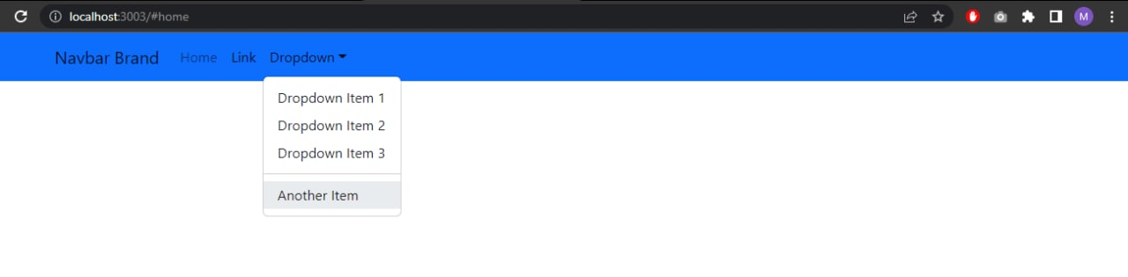

**13) Write a react program to create Form with Name, address, Gender, Subjects (dropdown box), Hobbies (check box) submit the form and alert the inputted data.**

**Code:**

**App.js**

function BasicExample() {

return (

<Form>

<Form.Group className="mb-3" controlId="formBasicName">

<Form.Label>Name</Form.Label>

<Form.Control type="name" placeholder="Enter Your Name" />

</Form.Group>

<Form.Group className="mb-3" controlId="formBasicAddress">

<Form.Label>Address</Form.Label>

<Form.Control type="address" placeholder="Enter Your Address" />

</Form.Group>

<Form.Group className="mb-3" controlId="formBasicGender">

<Form.Label>Gender</Form.Label>

<Form.Control type="gender" placeholder="Enter Your Gender" />

</Form.Group>

<Form.Group className="mb-3">

<Form.Label>Subject</Form.Label>

<Form.Select disabled>

<option>Science</option>

</Form.Select>

</Form.Group>

<Form.Group className="mb-3">

<Form.Label>Hobbies</Form.Label>

<Form.Check type="checkbox" label="Cricket" />

<Form.Check type="checkbox" label="Football" />

</Form.Group>

<Button variant="primary" type="submit">

Submit

</Button>

</Form>

);

}

export default BasicExample;

**Screenshot:**

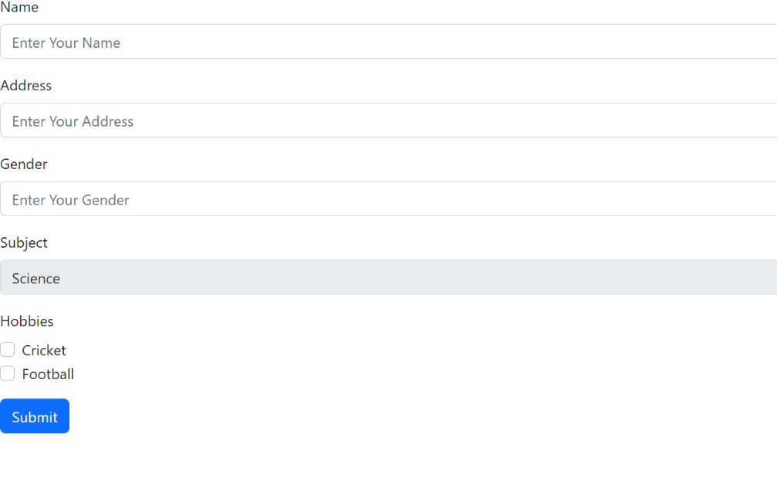

**14 ) Write a React program to count button click event using ‘useState’ hook.**

**Code :**

**Count.js**

import React, { useState } from "react";

import ReactDOM from "react-dom";

import "../src/App.css";

function App() {

// State to store count value

const [count, setCount] = useState(0);

// Function to increment count by 1

const incrementCount = () => {

// Update state with incremented value

setCount(count + 1);

};

return (

<div className="app">

<button onClick={incrementCount}>Click Here</button>

{count}

</div>

);

}

const rootElement = document.getElementById("root");

ReactDOM.render(<App />, rootElement);

export default App;

**Screenshot:**

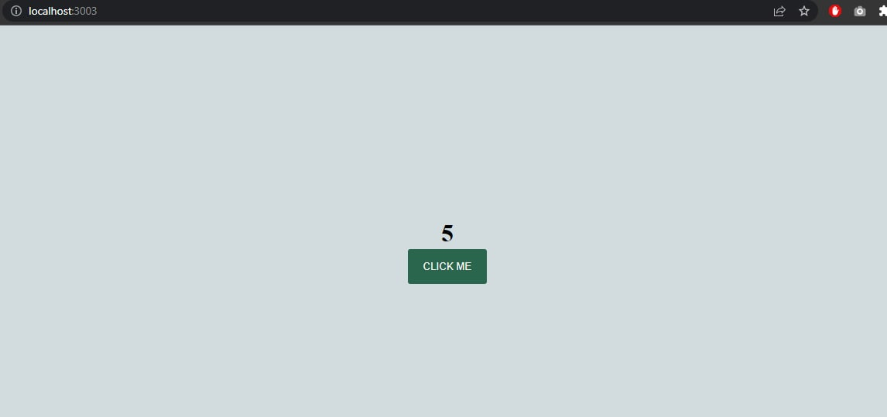

**15) Write a React program to create Timer using ‘useEffect’ hook.**

**Code:**

**CountDownTimer.js**

import React from 'react';

import './style';

const Timer = () => {

return (

<div className="container">

<div className="time">

<span className="minute">00</span>

<span>:</span>

<span className="second">00</span>

</div>

<div className="buttons">

<button onClick={() => null} className="start">Start</button>

<button onClick={() => null} className="reset">Reset</button>

</div>

</div>

)

}

export default Timer;

**App.js :-**

import React, { useState, useEffect } from 'react';

const Timer = () => {

function stopTimer() {

setIsActive(false);

setCounter(0);

setSecond('00');

setMinute('00')

}

return (

<div className="container">

<div className="time">

<span className="minute">{minute}</span>

<span>:</span>

<span className="second">{second}</span>

</div>

<div className="buttons">

<button onClick={() => setIsActive(!isActive)} className="start">

{isActive ? "Pause": "Start"}

</button>

<button onClick={stopTimer} className="reset">Reset</button>

</div>

</div>

)

**Screenshot:**

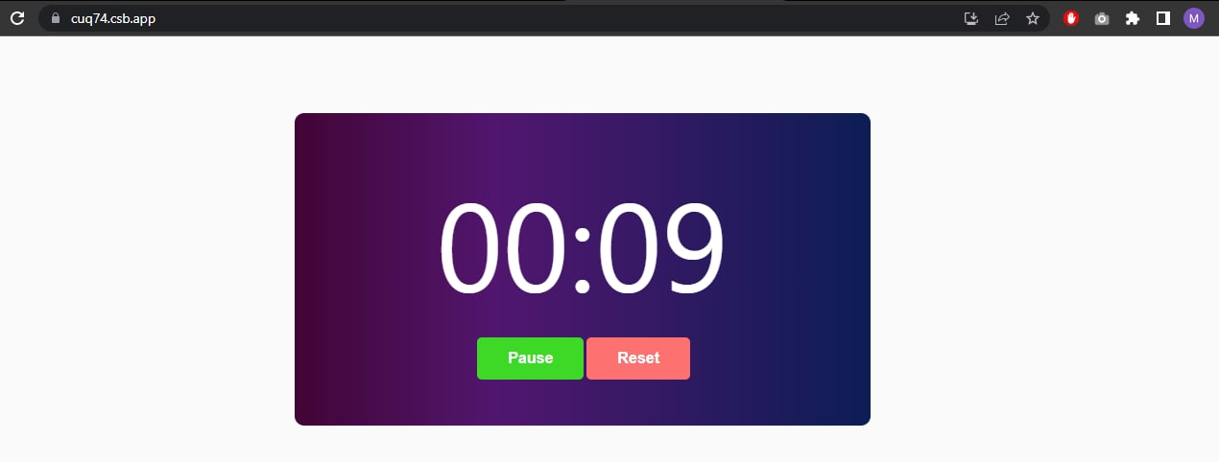

**16) Create Single page application (Website) using Angular js.**

**Code:**

Index.html:

<html lang="en">

<head>

<meta charset="UTF-8">

<title>Single page web app using Angularjs</title>

<script src="//ajax.googleapis.com/ajax/libs/angularjs/1.3.3/angular.min.js"></script>

<script src="//cdnjs.cloudflare.com/ajax/libs/angular.js/1.3.3/angular-route.min.js"> </script>

<script src="script.js"></script>

</head>

<body ng-app="single-page-app">

<div ng-controller="cfgController">

<div>

<ul>

<li><a href="#/">Home</a></li>

<li><a href="#/about">About us</a></li>

</ul>

</nav>

</div>

<br/>

<div ng-view>

</div>

</div>

</body>

</html>

Script.js

var app=angular.module('single-page-app',['ngRoute']);

app.config(function($routeProvider){

$routeProvider

.when('/',{

templateUrl: 'home.html'

})

.when('/about',{

templateUrl: 'about.html'

});

});

app.controller('cfgController',function($scope){

});